Pelvic Pain during Pregnancy

This information sheet is to give information to pregnant women who are experiencing pain around the pelvis whether that is at the front, over the symphysis and/or in the lower back, over the sacroiliac joints.

Classic signs and symptoms of this condition are:
- Pain in the front of the pelvis
- Pain in the lower back
- Pain in the groin
- Pain over the inner thighs
- Pain between the legs
- Clicking/grinding over the front of the pelvis

Women often describe having difficulty doing the following activities:
- Walking distances (often a “waddling” gait is common)
- Climbing up and down the stairs
- Getting in and out of the car
- Climbing in and out of the bath
- Turning over in bed
- Standing for long periods
- Dressing

Symptom and severity vary between women and pregnancies. Many pelvic problems are dismissed as the “normal aches and pains” of pregnancy, but you can adopt lifestyle changes and carry out simple exercises to reduce pain and improve function. With appropriate treatment the pressures on the pelvis are minimized so that the discomfort is manageable.

What causes the Pain?
During pregnancy, from about 12 weeks, the body produces a hormone call Relaxin which “softens” the strong ligaments around the joints of the pelvic ring. This is completely normal in preparation for the birth of the baby. When the ligaments become “stretched” they are not able to offer as much support to the joints of the pelvis and more stress is placed on them.

As the pregnancy progresses, the pelvis tries to cope with the changes associated with the baby growing such as the altered shape and posture, the muscles stretching and the weight gain. During this time, the pelvic joints rely more and more on the muscle function to compensate, but if this is inadequate, pain and instability may be felt around the pelvis.

You should aim to achieve good muscle function around the pelvis which together with some sensible lifestyle changes reduces excessive stress on the pelvic joints.

Top Tips
- Stand, sit and move evenly, keeping the pelvis symmetrical.
- Avoid standing for long periods.
- Avoid twisting movements; always face what you are doing.
- Keep your knees together when turning over in bed.
- Carry shopping equally in each hand and carry babies in front of you, not on your hip. Remember the more you carry the greater strain on your pelvic joints.
- Place a plastic bag on the car seat so that you can slide around out of the car keeping your knees together.
- Wear low heels and shock absorbing footwear to reduce stress through the pelvis.
- Go upstairs one step at a time and plan your day so they you can reduce the amount of times you have to use them.
- Use anti- slip mat in the bath/shower- a slip can be sore. Often the shower can be more comfortable as it is easier to step in and out of.
- Cuddle children sitting on your lap rather than lifting them.
- Avoid things you know will hurt such as squatting, vacuuming or other house hold chores. Listen to your body. A pain will take time to settle once it flares.
- Rest frequently throughout the day. Take the weight off your pelvis – lie down.
- Avoid breast stroke when swimming.
- When sleeping/resting on your side, use a small pillow between your knees.
- Avoid stretching exercises particularly those which take you knees apart.
- If walking is a problem, take smaller steps and avoid rushing. If pain is severe you may need crutches.
- Accept help form your partner/family/friends particularly in stressful postures or strenuous shopping trips etc.
- Sit down for task you would normally stand for e.g. preparing food, ironing, dressing etc.
- Only do essential lifting to avoid strain on joints.

- Maintain a good posture.
- In short, avoid straddle movements or activities where you stretch your knees apart. Measure and try to stay within that range during you daily activities.

Exercises
The use of exercise is important to improve muscle function and ease discomfort. You should practice exercises regularly, aim for 3-4 sessions a day.

Pelvic Floor Exercises
A pelvic floor muscle contraction is performed by closing and drawing up your front and back passage. Imagine you are trying to stop yourself from passing wind and at the same time trying to stop your flow of urine. The feeling is one of ‘’squeeze and lift’. In the beginning it may be easier to do the exercises in lying, but you can progress them to sitting and standing.

There are two types of exercises you should do;
- Quick and strong
Squeeze as hard as you can and then relax. Rest a second and then repeat up to 10 times.
2. Endurance
Squeeze and hold for up to 10 seconds. You must feel the muscle relax after each contraction. Aim to repeat it as many times as you can, building up to a maximum of 10 times.

DO NOT Pull in your stomach excessively
DO NOT Squeeze your legs together
DO NOT Tighten your buttocks
DO NOT Hold your breath.

You must aim to do these exercises at least 3 times a day. Generally, it takes 3-6 months to get a muscle really strong again. Do not do so many that the muscle begins to ache, remember it is quality not quantity!

Deep Stomach Muscles (Transversus Abdominis)
In sitting/standing/lying place your hands around the lower part of your bump below the belly
button. Breathe in gently. As you breathe out pull the lower part of the stomach, drawing your
‘bump’ in towards your spine, away from your hands. Do not move your back. With the muscle held,
continue to breathe normally.
Aim for hold for 3-5 breath cycles. Repeat 5-10 times.

Pelvic Tilting
In tall sitting, standing or on all fours, arching your lower back and stick your chest out. Then, slump,
rounding your spine and relaxing your shoulders. Repeat 5-10 times.
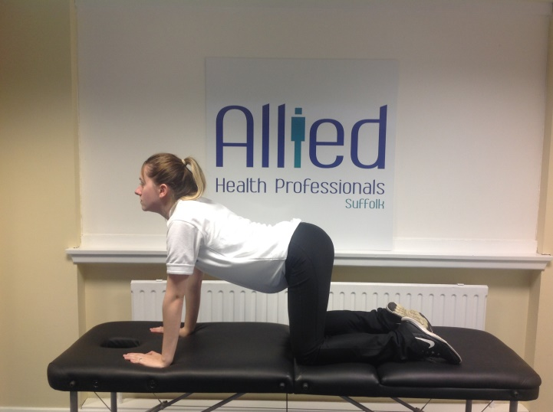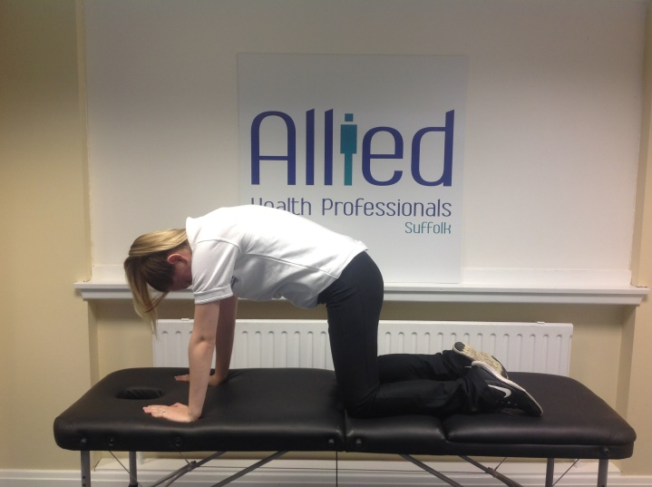

Sit to Stand
Begin sitting in a chair or on the edge of your bed. Slowly stand from the chair, and then slowly return to sitting. Try to keep the movement smooth and controlled. Try to stand without the help of your arms by crossing them across your chest.
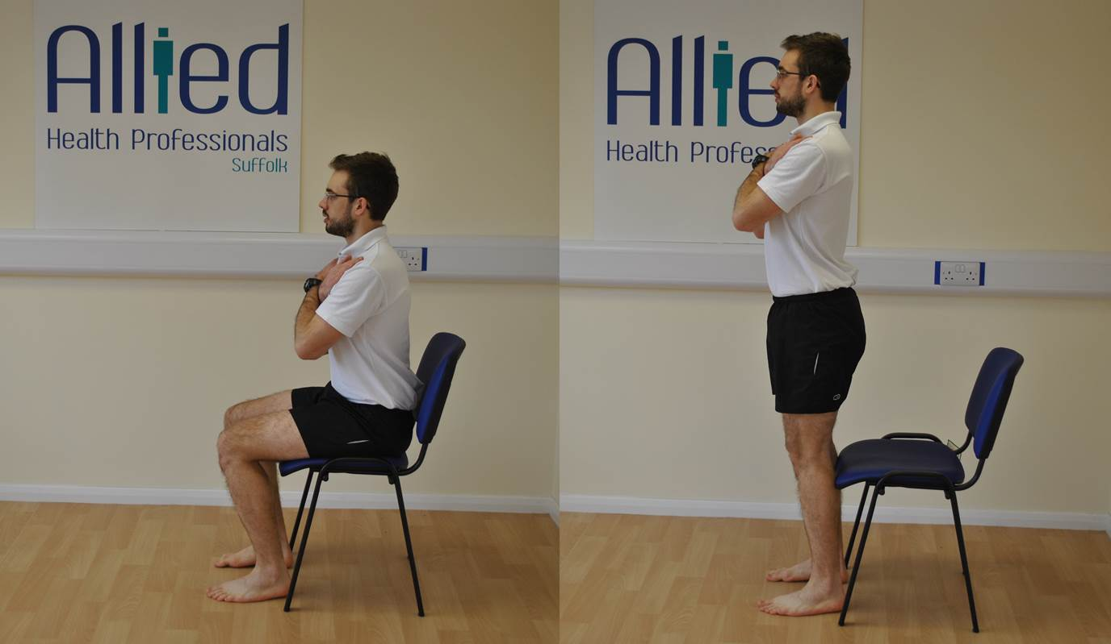

Remember:
- Use the deep stomach muscles and pelvic floor muscles by engaging them before and during the activities that give you discomfort. This action can help support the pelvis and prevent pain.
- Exercise within your pain limits. Be guided by your pain as to what you can do.
- Avoid activities where your legs move apart more than is comfortable. Some gym equipment and breaststroke may involve this.
- Build up exercise slowly as some pain takes a while to come on.
- Antenatal exercise classes run by those qualified are a good way to exercise. Always tell instructors about your pelvic pain.

There are many types of Maternity Support Belts available to buy. You can ask your Physiotherapist for advice. All supports need to be fitted correctly, so follow instructions carefully.

Sleeping
Being comfortable at night and getting a good night’s rest can make such a difference when coping with pelvic pain.
- Speak to your GP/Specialist about painkillers if required.
- Use a pillow or folded towels between your knees when lying on your side
- You may benefit from a pillow under your “bump” too.
- Remember to keep your knees together as your turn over.

Sexual Relationships
Sex is often affected by pelvic pain as it is often difficult to move comfortably. Try different positions and avoid positions where your legs are apart, or discomfort increased.

The Birth
Many women successfully give birth without any intervention despite having pelvic pain. To achieve this, discuss the options with your Midwife and Physiotherapist in the Antenatal period. It may be advisable to record that you have pelvic pain in your obstetric folder and also in your birth plan.

You will need to use positions during labour that do not put excessive pressure on the pelvis. If your Midwife is aware of the problem she can ensure that you are not kept in uncomfortable positions for long periods of time.

Some helpful positions to consider are:
- Kneeling in an upright position, supporting the upper body on a beanbag or chair or pillows
- On hands and knees

- Side lying with the upper leg supported by pillows
- Standing with the upper body leaning forward on a bed/support.
- Squatting with back straight and supported

If you have an assisted delivery (Ventose or forceps) or have to have your feet placed in stirrups it may be best to move both legs together and rotate your hips outwards as they are bent up. This is better than just separating them.
An epidural is not necessary but if you want one pelvic pain won’t prevent you.
It is rare to need a Caesarean section because of pelvic pain. Gather as much information before making decisions and remember it is a major operation.

Remember throughout your labour to:
- Allow the sacrum at the back of the pelvis to move freely, avoiding lying on your back for long periods
- Encourage effective contractions by making sure your back is straight and upright
- Measure the distance you can comfortably gap your knees. Record it in your notes or birth plan and be careful not to exceed it during labour. Whilst you have pain relief relieving the discomfort you will not automatically remember. Perhaps your Birth Partner could help to remind everyone of any excessive movement also.

Post Natal Period
Often immediately after the birth women find that they begin to feel more comfortable. For others it may take a little longer. It is essential to continue to work on the stability exercises to ensure you are making a steady recovery.
Very few women need continuing physiotherapy treatment after the birth. If you continue to have issues after birth please refer yourself to physiotherapy
Remember good posture when you are breastfeeding, lifting and changing the baby and pushing prams.

Future Pregnancies
It is not inevitable that your will experience pelvic pain in any further pregnancies. However, it is wise to allow your body to recover before embarking on another pregnancy. Remember that “prevention is better than the cure” and that is you are planning another child, prepare your body by beginning the stability exercises early. You may well find with a little foresight your symptoms do not reappear or are not as severe.

